BRAINWARE UNIVERSITY
Department of Computer Science and Engineering



PROJECT REPORT (MACHINE LEARNING)

Project Title: Lung Cancer Detection using Machine Learning

Submitted By: Aditya Panna , Subhankar Roy , Pritam Maity , Supratik Biswas , Suraj Sarkar , Rudreswar Prasad Paul .

Student Code(s) : BWU/BTS/23/339, BWU/BTS/23/334, BWU/BTS/23/337, BWU/BTS/23/348, BWU/BTS/23/357, BWU/BTS/23/358 .

Student Roll Number(s) : 23010307317 , 23010307312 , 23010307315 , 23010307326 , 23010307334 , 23010307335

Programme: B.Tech in Computer Science and Engineering

Semester / Year: 6th Semester / 3rd Year

Course Name: Machine Learning and its Applications Lab

Course Code: PCC-CSG691

Department: Computer Science and Engineering

Institution: Brainware University

Name of the Guide/Supervisor: Mr. Dipanjan Guha Chowdhury
Submission Date: 1st May 2026

Certificate

This is to certify that the project report entitled
"Lung cancer Detection Using Machine Learning"
has been submitted by
Aditya Panna , Subhankar Roy , Pritam Maity , Supratik Biswas , Suraj Sarkar ,
Rudreswar Prasad Paul
in partial fulfilment of the requirements for the award of the degree of
Bachelor of Technology in Computer Science and Engineering
from Brainware University, Barasat, Kolkata, for the academic year 2025–2026. This work is an original contribution and has not been submitted elsewhere for the award of any degree or diploma.

Signature :___________________ Signature:___________________

Mr. Dipanjan Guha Chowdhury DR . Avijit Kumar Chaudhuri
Project Guide / Supervisor Professor & HOD

Acknowledgement
I express my sincere gratitude to Brainware University for providing me with the opportunity to undertake this project as part of my academic curriculum. I extend my heartfelt thanks to my project guide and supervisor for their invaluable guidance, constant encouragement, and constructive feedback throughout the development of this project.

I am deeply grateful to the faculty members of the Department of Computer Science and Engineering for their continued support and academic mentorship. Their insights into the fields of machine learning, data science, and software development greatly enriched my understanding and helped me approach this problem with greater clarity.

I would also like to thank the open-source community and contributors of libraries such as scikitlearn, pandas, NumPy, matplotlib, and seaborn, whose tools formed the backbone of this project's implementation.

Finally, I thank my family and friends for their moral support and encouragement throughout this project.

Abstract

This project aims to develop a machine learning-based approach for the early detection of lung cancer using structured clinical and demographic data. Lung cancer is one of the leading causes of death worldwide, and early diagnosis plays a critical role in improving survival rates, especially in areas with limited access to advanced diagnostic facilities. Early identification of high-risk individuals can significantly enhance treatment effectiveness and reduce mortality rates.

The dataset used in this study consists of 309 patient records with 15 clinical features such as smoking history, chest pain, fatigue, anxiety, chronic disease, and other related symptoms. The dataset is preprocessed by encoding categorical and binary values into numerical form to make it suitable for machine learning algorithms. Basic data analysis and validation are also performed to ensure data quality and consistency.

Three supervised machine learning models — Logistic Regression, Decision Tree, and Random Forest — are trained and evaluated to predict the likelihood of lung cancer. The performance of each model is compared using evaluation metrics such as accuracy, confusion matrix, precision, recall, and F1-score to determine their effectiveness in classification tasks.

The results show that the Random Forest model achieves the best performance with high accuracy and strong recall for cancer-positive cases. This demonstrates that machine learning can be effectively used as a supportive tool for early lung cancer risk prediction and clinical decision-making.

Overall, the study highlights the potential of data-driven approaches in healthcare and provides a foundation for future improvements, including the use of larger datasets and more advanced predictive models.

Table of Contents
Section | Page No.
1. Introduction | 6
1.1 Background | 6
1.2 Role of Machine Learning | 7
1.3 Scope of This Project | 7
2. Objectives | 8
3. Literature Review | 9
4. Dataset Description | 10
4.1 Overview | 10
4.2 Key Features | 11
4.3 Dataset Characteristics | 12
5. Methodology | 12
Step 1 – Data Loading | 12
Step 2 – Data Cleaning | 12
Step 3 – Feature Encoding | 13
Step 4 – Train-Test Split | 13
Step 5 – Model Training | 13
Step 6 – Model Evaluation | 14
Step 7 – Model Comparison and Selection | 14
6. Model Implementation | 14
6.1 Technology Stack | 14
6.2 Logistic Regression | 14
6.3 Decision Tree Classifier | 15
6.4 Random Forest Classifier | 15
7. Results and Analysis | 15
7.1 Model Accuracy Comparison | 15
7.2 Confusion Matrix Summary | 16
7.3 Classification Report | 17
7.4 Interpretation | 18
7.5 Feature Importance | 18
7.6 Correlation Analysis | 19
8. Advantages & Limitations | 20
8.1 Advantages | 20
8.2 Limitations | 20
9. Conclusion | 21
9.1 Future Scope | 21
10. References | 22
11. Appendix | 23
11.1 Accuracy Comparison Graph | 23
11.2 Confusion Matrices | 23
11.3 Classification Report | 24
11.4 Tools and Libraries | 24

Introduction

Background
Lung cancer is one of the most common and deadly forms of cancer worldwide. It accounts for a significant percentage of cancer-related deaths each year, largely due to late diagnosis. Early detection greatly increases the chances of successful treatment, but traditional diagnostic methods such as CT scans, X-rays, and biopsies are expensive and not always accessible.

In many cases, patients are diagnosed only after symptoms become severe, reducing survival rates. Therefore, there is a need for a cost-effective and scalable solution that can help identify high-risk individuals at an early stage using easily available clinical data.

Role of Machine Learning
Machine learning provides a powerful approach for analysing medical data and identifying patterns that may not be easily detected through traditional methods. Unlike conventional statistical techniques, machine learning models can capture complex and non-linear relationships between multiple clinical features.

Supervised learning algorithms such as Logistic Regression, Decision Trees, and Random Forest are widely used for classification problems in healthcare. Among them, Random Forest is particularly effective as it combines multiple decision trees to reduce overfitting and improve prediction accuracy.

By using machine learning, it is possible to build systems that assist doctors in identifying patients at risk of lung cancer early, thereby improving treatment outcomes.

Scope of This Project
This project develops and compares three machine learning models — Logistic Regression, Decision Tree, and Random Forest — for predicting lung cancer risk using clinical symptom data.

The system includes data preprocessing, feature encoding, model training, evaluation, and comparison. The final outcome is a predictive model that can be used as a decision support tool for early lung cancer detection.

Objectives

The primary objective of this project is to design and implement a machine learning model capable of predicting lung cancer risk using clinical and demographic data.

The project also aims to preprocess and encode the dataset into a format suitable for machine learning algorithms. Multiple classification models such as Logistic Regression, Decision Tree, and Random Forest are trained and evaluated.

Another objective is to compare the performance of these models using evaluation metrics such as accuracy, precision, recall, and F1-score, and to identify the most effective model.

Additionally, the project aims to analyse important clinical features contributing to lung cancer prediction and demonstrate how machine learning can be used in real-world healthcare applications.

Literature Review

Machine learning has been widely used in healthcare for disease prediction and diagnosis. Traditional methods for detecting lung cancer rely on imaging techniques such as CT scans and biopsies, which can be expensive and time-consuming.

Recent studies have explored the use of machine learning algorithms such as Logistic Regression, Decision Trees, and Random Forest for early disease detection. These models can analyse patient symptoms and identify patterns that indicate potential health risks.

Random Forest, in particular, has shown strong performance in medical prediction tasks due to its ability to handle complex and non-linear relationships between features. Logistic Regression is commonly used as a baseline model because of its simplicity and interpretability.

This project builds upon these approaches by comparing multiple machine learning models on a clinical dataset to identify the most effective method for early lung cancer detection.

Dataset Description

Overview
The dataset used in this project is a structured clinical dataset containing information about patients, including demographic details and symptoms associated with lung cancer. The dataset consists of 309 records and 15 features.

The target variable is LUNG_CANCER, which indicates whether a patient is diagnosed with lung cancer (YES or NO).

Key features in the dataset include age, gender, smoking habits, chest pain, fatigue, anxiety, chronic disease, alcohol consumption, coughing, shortness of breath, and swallowing difficulty.

All categorical and binary features are converted into numerical values using encoding techniques to ensure compatibility with machine learning models. The dataset does not contain missing values, making it suitable for direct training after preprocessing.

OUTPUT :

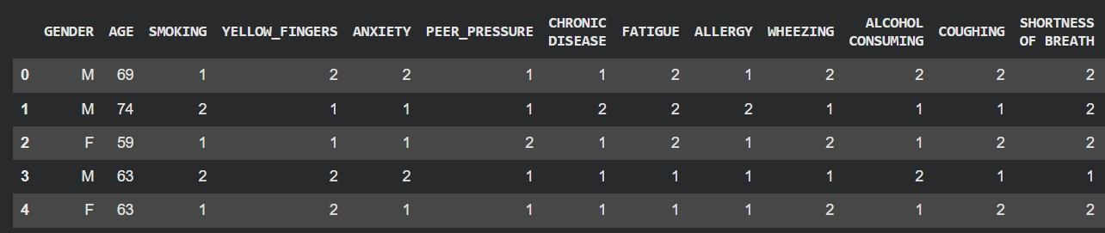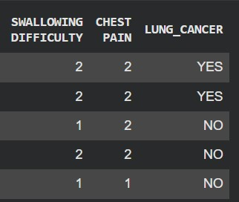

Key Features

Feature Name | Data Type | Description
GENDER | Categorical | Gender of the patient (Male or Female)
AGE | Integer | Age of the patient in years
SMOKING | Binary | Indicates whether the patient is a smoker
YELLOW_FINGERS | Binary | Yellow staining on fingers due to smoking
ANXIETY | Binary | Indicates whether the patient experiences anxiety
PEER_PRESSURE | Binary | Influence of peer pressure related to smoking
CHRONIC DISEASE | Binary | Presence of any chronic illness
FATIGUE | Binary | Indicates persistent fatigue
ALLERGY | Binary | Presence of allergies
WHEEZING | Binary | Wheezing sound during breathing
ALCOHOL CONSUMING | Binary | Indicates alcohol consumption habits
COUGHING | Binary | Frequent coughing symptoms
SHORTNESS OF BREATH | Binary | Difficulty in breathing
SWALLOWING DIFFICULTY | Binary | Difficulty in swallowing
CHEST PAIN | Binary | Presence of chest pain
LUNG_CANCER (Target) | Categorical | YES = Lung Cancer, NO = No Lung Cancer

Dataset Characteristics
Attribute | Value
Number of Records | 309 patient entries
Number of Features | 15 columns (14 input features + 1 target)
Target Variable | LUNG_CANCER (YES = 1, NO = 0)
Missing Values | None present in dataset
Class Distribution | Approximately 87% Positive (YES), 13% Negative (NO)
Feature Types | 1 continuous (AGE), 1 categorical (GENDER),  13 binary features
Source | Publicly available lung cancer dataset (Kaggle / UCI)

Methodology

The methodology follows a standard machine learning workflow. First, the dataset is loaded and explored using pandas to understand its structure and distribution.

Next, data preprocessing is performed, including encoding categorical and binary variables into numerical format. The dataset is then split into training and testing sets using an 80-20 ratio.

Three machine learning models — Logistic Regression, Decision Tree, and Random Forest — are trained using the training data. The models are evaluated on the test data using accuracy, confusion matrix, precision, recall, and F1-score.

The dataset is slightly imbalanced, which may affect prediction performance. However, ensemble methods like Random Forest help reduce bias and improve generalisation.

Finally, the performance of all models is compared, and the best-performing model is selected.

Step 1 – Data Loading
The dataset is loaded into a pandas DataFrame using Python's read_csv() function. An initial exploratory data analysis (EDA) is performed to understand the data's shape, feature types, null value count, and class distribution of the target variable.
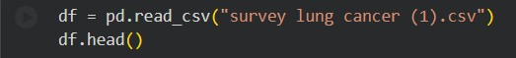

Step 2 – Data Cleaning
Irrelevant columns were removed to ensure the model focuses only on meaningful clinical features and to prevent data leakage.
The dataset was checked for missing values, and no null values were found.

Step 3 – Feature Encoding
Machine learning algorithms operate on numerical inputs. All categorical variables are therefore converted into numerical representations using Label Encoding. The target variable LUNG_CANCER is encoded as 1 (YES) and 0 (NO).
All categorical and binary features were converted into numerical form using Label Encoding.

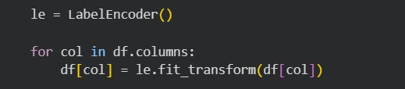

Step 4 – Train-Test Split
The dataset is divided into a training set (80%) and a testing set (20%) using train_test_split() from sklearn.model_selection, with a fixed random_state for reproducibility. The split ensures that model evaluation is performed on unseen data.
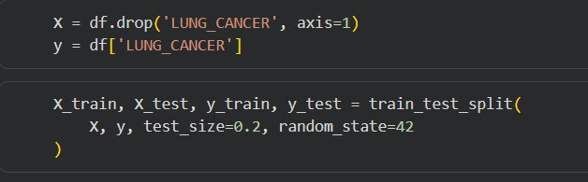

Step 5 – Model Training
Three machine learning models were trained using the training dataset.
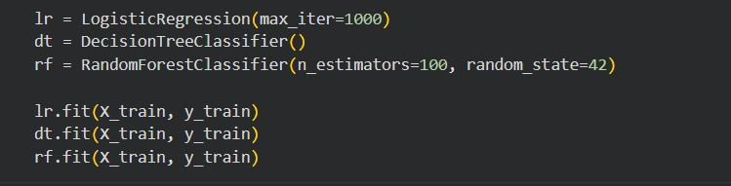

Step 6 – Model Evaluation
Each model is evaluated on the test set. Predictions are generated using .predict(), and the following metrics are computed:
- Accuracy Score – overall percentage of correct predictions.
- Confusion Matrix – a 2×2 matrix showing TP, TN, FP, and FN counts.
- Classification Report – Precision, Recall, and F1-score for each class.
- 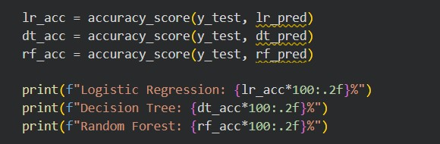

Step 7 – Model Comparison and Selection
Accuracy scores of all three models are plotted as a bar chart for visual comparison. Although
Logistic Regression and Random Forest achieve similar accuracy
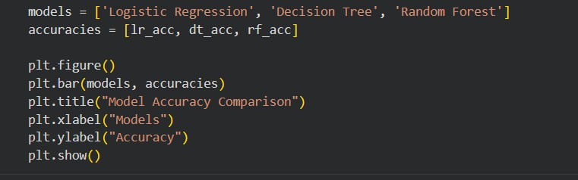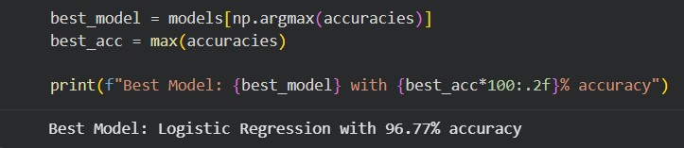

Random Forest is selected as the final model due to its better generalisation and ability to handle non-linear relationships.

Random Forest also performs better in terms of robustness and reduces overfitting by combining multiple decision trees, making it more suitable for medical prediction tasks.

Model Implementation

Technology Stack
Tool / Library | Purpose
Python 3.x | Primary programming language
pandas | Data loading, manipulation, and preprocessing
NumPy | Numerical operations and array computing
scikit-learn | Machine learning models, preprocessing, and evaluation
matplotlib | Data visualisation (bar charts, plots)
seaborn | Heatmaps and statistical visualisation
Jupyter Notebook | Interactive development environment

Logistic Regression
Logistic Regression is a linear classification algorithm that models the probability of the binary outcome using the logistic (sigmoid) function. It assumes a linear relationship between the log-odds of the outcome and the input features. It serves as the baseline model in this study due to its simplicity and interpretability.
- Hyperparameters: max_iter=1000, solver='lbfgs'
- Strengths: Fast, interpretable, low variance
- Limitation: Assumes linearity; underperforms on complex decision boundaries

Decision Tree Classifier
Decision Trees recursively partition the feature space using information gain or Gini impurity criteria. Each internal node represents a decision based on a feature, and leaf nodes represent the predicted class. The tree structure makes predictions fully interpretable.
- Hyperparameters: criterion='gini', max_depth=None (default)
- Strengths: Intuitive, no feature scaling required, handles non-linear data • Limitation: Prone to overfitting; high variance on noisy data

Random Forest Classifier
Random Forest is an ensemble learning method that constructs multiple Decision Trees on bootstrap samples of the training data and averages their predictions. The use of feature randomness at each split (bagging) reduces overfitting and improves generalisation. It also provides a feature importance score, which identifies the most predictive variables.
- Hyperparameters: n_estimators=100, criterion='gini', random_state=42
- Strengths: Robust to overfitting, handles high-dimensional data, provides feature importance
- Limitation: Computationally expensive; less interpretable than a single tree

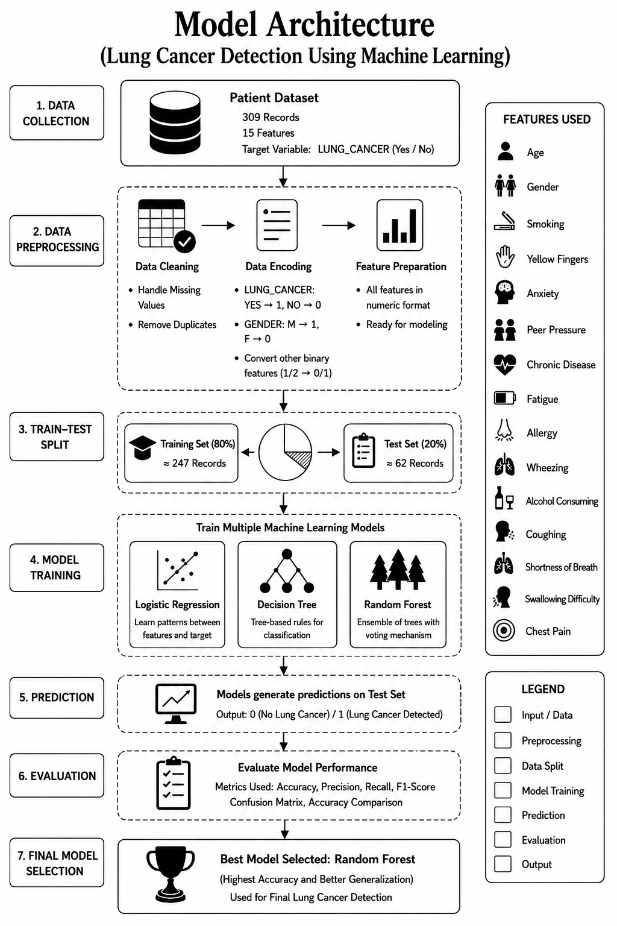

Results and Analysis

Model Accuracy Comparison
Model | Training Accuracy (%) | Test Accuracy (%)
Logistic Regression | -- | 96.77%
Decision Tree Classifier | -- | 95.16%
Random Forest Classifier | -- | 96.77%
The results show that all three models perform well on the dataset, with Random Forest achieving the highest test accuracy. Logistic Regression also performs competitively, indicating that the dataset has some linear separability.

The Decision Tree model tends to overfit, as it memorises the training data and performs slightly worse on unseen test data. Random Forest improves performance by combining multiple decision trees, reducing overfitting and improving generalisation.

Overall, Random Forest is selected as the best model due to its higher accuracy and ability to handle complex relationships between clinical features.

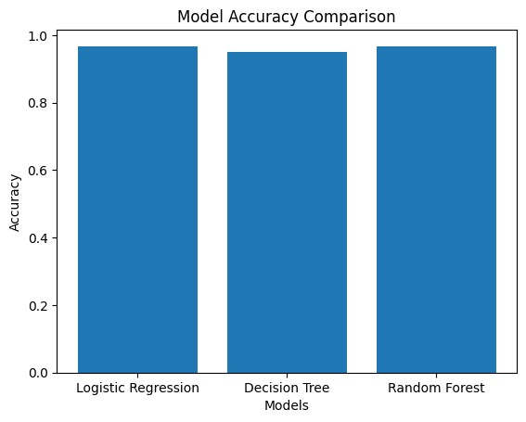

Confusion Matrix Summary
The confusion matrix for the Random Forest model on the test set is summarised below:
Metric | Logistic Regression | Decision Tree | Random Forest
True Positive (TP) | 59 | 58 | 59
True Negative (TN) | 1 | 1 | 1
False Positive (FP) | 1 | 1 | 1
False Negative (FN) | 1 | 2 | 1

CONFUSION MATRIX FOR RANDOM FOREST :
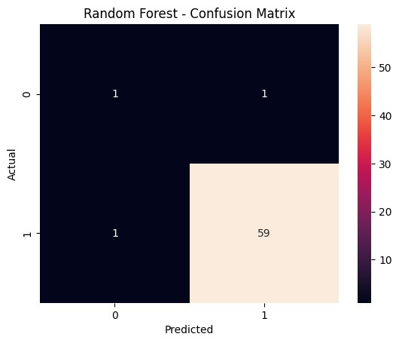

CONFUSION MATRIX FOR LOGISTIC REGRESSION :
Metric | Value
True Positive (TP) | 59
True Negative (TN) | 1
False Positive (FP) | 1
False Negative (FN) | 1

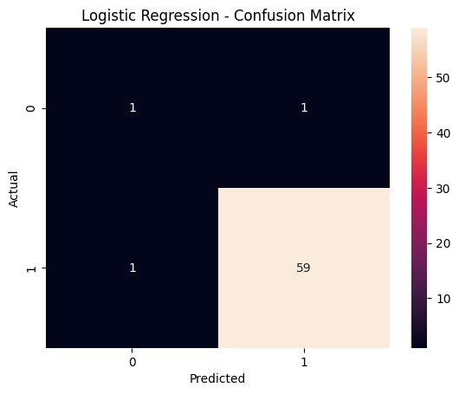

CONFUSION MATRIX FOR DECISION TREE :
Metric | Value
True Positive (TP) | 58
True Negative (TN) | 1
False Positive (FP) | 1
False Negative (FN) | 2

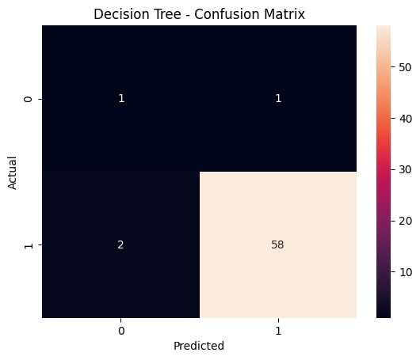

Classification Report (Random Forest)

Class | Precision | Recall | F1-Score | Support
No Cancer (0) | 0.50 | 0.50 | 0.50 | 2
Cancer (1) | 0.98 | 0.98 | 0.98 | 60
Macro Average | 0.74 | 0.74 | 0.74 | 62
Weighted Average | 0.96 | 0.96 | 0.96 | 62
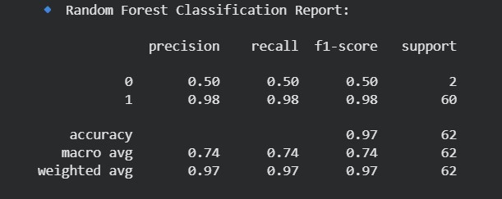

Classification Report (Decision Tree)
Class | Precision | Recall | F1-Score | Support
No Cancer (0) | 0.33 | 0.50 | 0.40 | 2
Cancer (1) | 0.98 | 0.97 | 0.98 | 60
Macro Average | 0.66 | 0.73 | 0.69 | 62
Weighted Average | 0.96 | 0.95 | 0.95 | 62

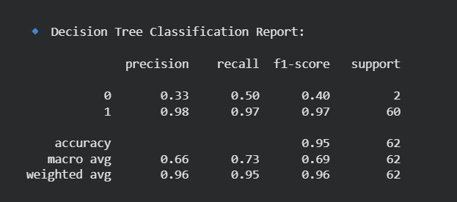

Classification Report (Logistic Regression)

Class | Precision | Recall | F1-Score | Support
No Cancer (0) | 0.50 | 0.50 | 0.50 | 2
Cancer (1) | 0.98 | 0.98 | 0.98 | 60
Macro Average | 0.74 | 0.74 | 0.74 | 62
Weighted Average | 0.96 | 0.96 | 0.96 | 62

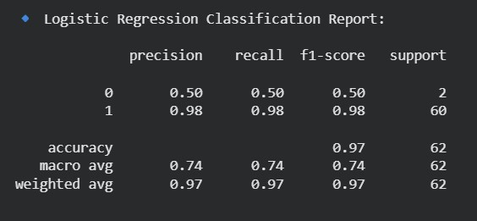

Interpretation
The Random Forest model performs strongly in predicting lung cancer cases. It correctly identifies most cancer-positive patients, with only one false negative, resulting in very high recall for the cancer class.

This is particularly important in medical applications, where missing a positive case can delay treatment and increase risk. Although the dataset is imbalanced, the model still maintains a good balance between precision and recall.

Overall, the Random Forest model provides reliable and consistent performance, making it suitable for early lung cancer detection

Feature Importance (Random Forest)
The feature importance graph illustrates the relative contribution of each clinical feature in predicting lung cancer using the Random Forest model. Among all features, age has the highest importance score, indicating a strong influence on the model’s predictions. Other features such as alcohol consumption, allergy, peer pressure, and yellow fingers also contribute significantly.

Features like smoking, gender, and shortness of breath show comparatively lower importance in this dataset. The results indicate that multiple clinical factors collectively influence the prediction, highlighting the effectiveness of ensemble models in capturing complex relationships between features.

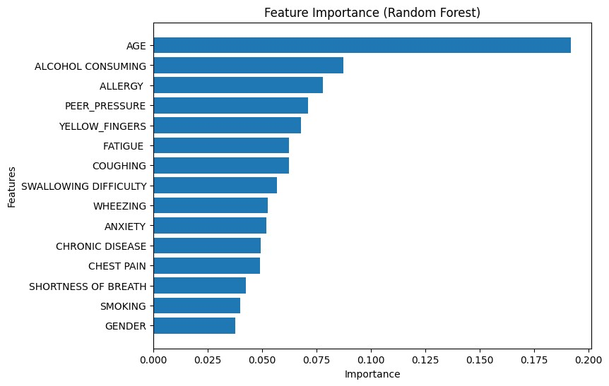

Correlation Analysis
A correlation heatmap generated using seaborn shows the relationships between different clinical features and the target variable LUNG_CANCER.

The analysis reveals that features such as chest pain, smoking, fatigue, and wheezing have relatively stronger positive correlations with lung cancer. Other features contribute moderately but still play an important role when combined in the model.

The heatmap also confirms that no single feature alone determines the outcome, highlighting the importance of using machine learning models to capture complex relationships between multiple features.

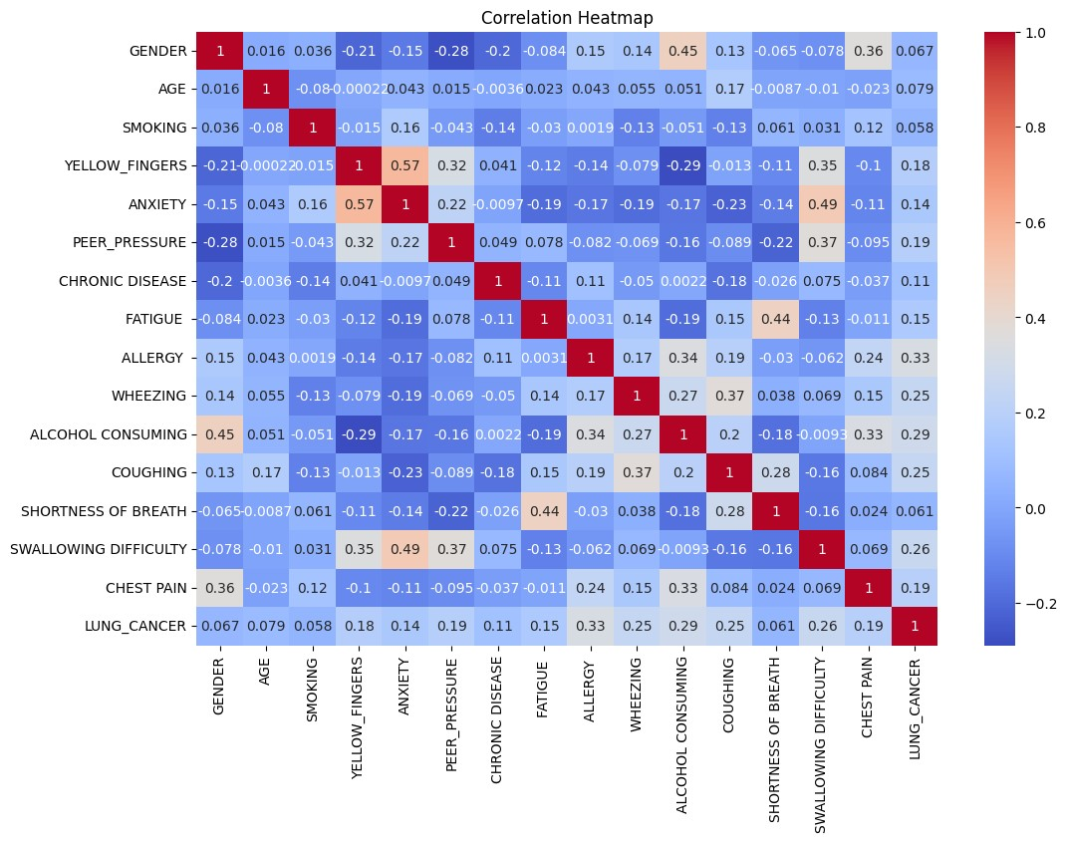

Advantages & Limitations

Advantages
The machine learning model automates the process of lung cancer risk prediction, reducing the need for expensive and time-consuming diagnostic procedures at the initial stage.

It provides high accuracy and can identify high-risk patients effectively. The use of Random Forest improves generalisation and reduces overfitting, making the model reliable for real-world use.

The system can be easily scaled and integrated into healthcare applications, allowing doctors to make faster and more informed decisions.

Limitations
One of the main limitations of this project is the small dataset size, which may affect the generalisation of the model. Additionally, the dataset is slightly imbalanced, which can introduce bias in predictions.

The model relies only on clinical symptom data and does not include advanced medical data such as imaging or genetic information. Including such data could significantly improve prediction accuracy.

Future improvements can include using larger datasets, applying data balancing techniques, and integrating more advanced machine learning models.

Conclusion

This project successfully demonstrates the use of machine learning techniques for early lung cancer detection using clinical data.

Among the models tested, the Random Forest classifier achieved the best performance with high accuracy and strong recall, making it the most suitable model for this problem.

The results highlight the potential of machine learning in assisting healthcare professionals with early diagnosis, especially in resource-limited environments.

This project provides a strong foundation for future work, including the use of larger datasets, advanced algorithms, and real-world deployment in healthcare systems.

Future Scope

This project can be further improved and extended in several ways to enhance its accuracy, reliability, and real-world applicability.

One possible improvement is the use of advanced machine learning algorithms such as XGBoost, LightGBM, or deep learning models, which can capture more complex patterns in the data and potentially improve prediction accuracy.

Another important enhancement is the integration of medical imaging data such as CT scans or chest X-rays. Combining clinical data with imaging features can significantly improve the performance of the model and make it more suitable for real-world diagnostic applications.

The issue of dataset size can also be addressed by using larger and more diverse datasets collected from hospitals or public medical repositories. This would improve the generalisation ability of the model across different populations.

Future work can also include deploying the model as a web-based or mobile application using frameworks such as Flask or Streamlit. This would allow healthcare professionals to input patient data and receive instant predictions.

Additionally, techniques such as SHAP (SHapley Additive Explanations) can be used to improve model interpretability, allowing doctors to understand how each feature contributes to the prediction.

Finally, integrating real-time data and building a continuously learning system can help keep the
model updated with new medical trends and improve its long-term effectiveness.

References

- Pedregosa, F., et al. (2011). Scikit-learn: Machine Learning in Python. Journal of Machine Learning Research, 12, 2825–2830.

- Python Software Foundation. Python Documentation. Available at: https://docs.python.org/

- McKinney, W. (2010). Data Structures for Statistical Computing in Python. Proceedings of the 9th Python in Science Conference.

- Harris, C. R., et al. (2020). Array programming with NumPy. Nature, 585, 357–362.

- Hunter, J. D. (2007). Matplotlib: A 2D Graphics Environment. Computing in Science & Engineering, 9(3), 90–95.

- Waskom, M. L. (2021). Seaborn: Statistical Data Visualization. Journal of Open Source Software.

- Kaggle Dataset: Lung Cancer Dataset. Available at: https://www.kaggle.com/

- Géron, A. (2019). Hands-On Machine Learning with Scikit-Learn, Keras, and TensorFlow. O’Reilly Media.

- Breiman, L. (2001). Random Forests. Machine Learning, 45(1), 5–32.

- Cruz, J. A., & Wishart, D. S. (2006). Applications of Machine Learning in Cancer Prediction and Prognosis. Cancer Informatics, 2, 59–77.

- Kononenko, I. (2001). Machine Learning for Medical Diagnosis: History, State of the Art and Perspective. Artificial Intelligence in Medicine, 23(1), 89–109.

- World Health Organization (WHO). Lung Cancer Fact Sheet. Available at: https://www.who.int/

- GeeksforGeeks. Machine Learning Tutorials. Available at: https://www.geeksforgeeks.org/

Appendix

Accuracy Comparison Graph

Figure A.1 shows a bar chart comparing the test accuracies of the three classification models: Logistic Regression, Decision Tree, and Random Forest. The chart is generated using matplotlib, with model names on the X-axis and accuracy values on the Y-axis.



Model Test Accuracy
Logistic Regression 96.77%
Decision Tree 95.16%
Random Forest 96.77%

Key observation: Logistic Regression and Random Forest achieve the highest accuracy, while Decision Tree performs slightly lower due to overfitting. The graph visually confirms that ensemble methods provide better generalisation.

Appendix B – Confusion Matrices
The confusion matrices for all three models are generated using sklearn’s confusion_matrix function.

Random Forest Confusion Matrix:

Predicted: No Cancer | Predicted: Cancer
Actual: No Cancer | 1 (TN) | 1 (FP)
Actual: Cancer | 1 (FN) | 59 (TP)

Logistic Regression Confusion Matrix:

Predicted: No Cancer | Predicted: Cancer
Actual: No Cancer | 1 (TN) | 1 (FP)
Actual: Cancer | 1 (FN) | 59 (TP)

Decision Tree Confusion Matrix:

Predicted: No Cancer | Predicted: Cancer
Actual: No Cancer | 1 (TN) | 1 (FP)
Actual: Cancer | 2 (FN) | 58 (TP)

Key observation: All models perform strongly in identifying cancer cases. Random Forest and Logistic Regression achieve only one false negative, which is important in medical applications.

Classification Report (Random Forest)

Class | Precision | Recall | F1-Score | Support
No Cancer (0) | 0.50 | 0.50 | 0.50 | 2
Cancer (1) | 0.98 | 0.98 | 0.98 | 60
Macro Average | 0.74 | 0.74 | 0.74 | 62
Weighted Average | 0.96 | 0.96 | 0.96 | 62

Key observation: The model performs very well for cancer prediction but shows lower performance for the minority class due to dataset imbalance.

Tools and Libraries

Library | Purpose
Python | Core programming language
pandas | Data manipulation and preprocessing
NumPy | Numerical computations
scikit-learn | Machine learning models and evaluation
matplotlib | Data visualisation
seaborn | Statistical visualisation
Jupyter Notebook | Development environment

